Caretakers Newsletter July 2020

New Apps on Website
During some of the training courses that we have been providing over the last few months, you may have heard talk of several apps. We have made them available to download in the handy tools section of the staff portal on our website, all of these are free to use. Below is the list:
St John’s Ambulance
This can be used in emergency situations when coming across a casualty, coming with a basic diagnosis of situations and guidance on how to deal with them.
StomaCare
This handy app can be used to assist clients with their stoma, comes in handy when we are not undertaking this task daily. It contains pictures and how-to videos as well as guidance on how people live with their stomas and many more.
iStumble
Brand new, out this month. This app has been designed by West Midlands Ambulance Service to assist carers when finding a fallen client. The aim is to reduce the number of callouts to ambulances for non-injurious falls using this step-by-step guide, hopefully saving each service around £20 million per year.
Domiciliary Care Toolkit
Having been around for years now. Containing pretty much everything Home Care related, this is your guidance on how to undertake your role.
In case you need it, we have also added the Slack download as well as a few more handy tools.
Updated Policies now on website
Due to COVID-19, updates to GDPR and other court cases, please be aware that the following policies have now been updated and are available to view on the website:
Assessment of need
Business Continuity
Confidentiality
Co-operating with Other Providers
Care and Support Planning
Consent
Falls Prevention
Infection Control
Disciplinary
DBS
Equality & Diversity
Grievance
Relatives, Friends and Unpaid Carers

Thank you to you all during the Lockdown Period
We want to say a special thank you to all of you who have worked over the lockdown period. We know it has been a difficult time for all but we have learned a lot from this episode and have put into practice new ways of doing things, including listening to you all when you said you enjoyed the online training. We now hope to see this continue for most of the courses.

New Mandatory Training Courses
Due to new industry guidance we have decided to make more courses mandatory for all staff these now include the following courses:
Pressure Care Management
Catheter, Conveen & Stoma Awareness

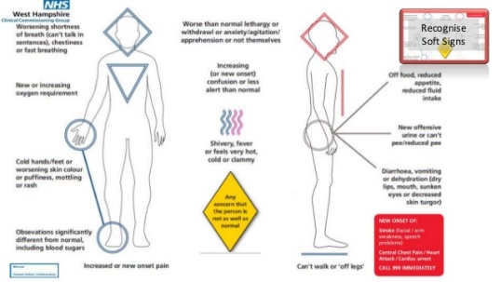
RESTORE 2
We know that some of you will have already undertaken some of these courses, please be aware that if you have not been booked yet, you will be soon!

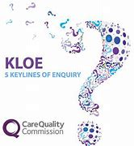
Key Lines of Enquiry 2020
Over this month we have been collecting data from clients to see what they think about the services we provide. The results are now in and you can see the information if you log in to our website and go to the KLOE’s page. The great news is that our service has improved in our client’s estimation! Well done to Everyone!

Summer Holiday Kids Programs

As the same as last year Kinetic Sports are back to entertain your children over the summer holidays, unfortunately due to the current circumstances and funding diverted to clinical needs, we were unable to secure funding to assist with payments. Therefore the price for Kinetic with be their standard rates. Though as a gesture of goodwill Caretakers will pay half!

Other options we have found so far are as follows:
Play Torbay – http://playtorbay.org.uk/holiday-programme/
Premier Education Holiday Camps - https://www.premier-education.com/parents/camps/search/?location=tq3+1bl&radius=10
Watcombe Nursery Summer Holiday Club – http://www.watcombenursery.co.uk
For kids who are into gaming, coding and computers there are also some virtual camps such as https://funtech.co.uk

