Falls Prevention & Post Falls Guidance

[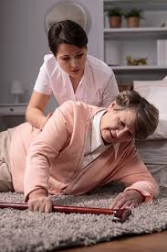](https://www.google.co.uk/url?sa=i&rct=j&q=&esrc=s&source=images&cd=&cad=rja&uact=8&ved=0ahUKEwigsdqatvPPAhVDuRoKHQ_FCOUQjRwIBw&url=https://daughterlycare.com.au/coroner-warning-elders-falls-in-nursing-homes&psig=AFQjCNHqsX-HzD4flXrj-nn0R49L5zmvsw&ust=1477397791953799)

[](https://www.google.co.uk/url?sa=i&rct=j&q=&esrc=s&source=images&cd=&cad=rja&uact=8&ved=0ahUKEwigsdqatvPPAhVDuRoKHQ_FCOUQjRwIBw&url=https://daughterlycare.com.au/coroner-warning-elders-falls-in-nursing-homes&psig=AFQjCNHqsX-HzD4flXrj-nn0R49L5zmvsw&ust=1477397791953799)

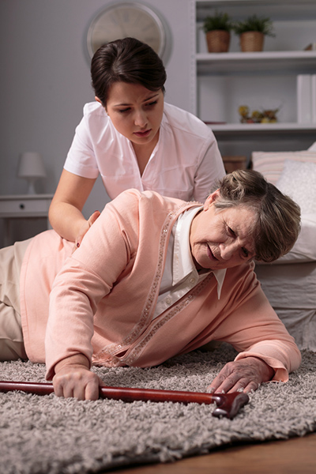

For Care

Agencies

3CP Training

**INTRODUCTION**

Even when all possible steps have been taken to prevent them, a certain number of falls are inevitable. A fall is defined as an event which results in a person coming to rest inadvertently on the ground or other lower level. This guidance has been developed to support Care Providers to assist Service Users when a fall happens within their care and to encourage the appropriate use of emergency services in these circumstances.

It can be used as a training tool and reference document for any Provider seeking clarification on best practice. It does not replace any pre-existing policies or guidance you may have where these are working well. Although this guidance provides a good basis for the majority of situations carers should encounter, it cannot foresee every possibility and must always be used in combination with clinical judgement (in nursing homes), common sense and in line with your duty of care.

This guidance has been developed from a variety of sources including reports from The National Patient Safety Agency and the National Institute for Health and Care Excellence. Much of the evidence base comes from the inpatient environment but has been adapted here for care homes.

Falls Prevention

We shall now look at the three factors that contribute to falls within the care industry; these are Accidents, Illness & Medication and Reduced Mobility.

Accidents

What is an Accident?

An accident is an unplanned and uncontrolled event that has led to or could have caused injury to persons, damage to business or other loss.

Causes of Accidents

* Slips and trips
* Poor handling, lifting and carry techniques
* Struck by moving or falling object
* Misuse of machinery such as a hoist
* Sharp objects
* Using harmful substances
* Not following instructions
* Stress

Identifying the Causes of Accidents

There are three factors to be considered when identifying the causes of accidents

Environment factors:

These are associated with the area in which we work and include safe floors, safe entry and exit routes, noise, facilities, space, lighting, heating and ventilation

Human factors:

These refer to the behaviour and ability of the individual, what we do and why we do it. These include:

* Lack of knowledge: due to insufficient training or instructions
* Lack of concentration: due to complacency, boredom, monotony or distraction
* Horseplay: people fooling around in the workplace
* Lack of capability: sometimes even well trained people cannot do the job safely

Occupational factors:

* These are directly related to the job or task and include:
* Manual handling of loads
* Using equipment
* Using hazardous substances
* For example, administering medication

The biggest way to reduce any potential falls via accidents is to be observant of our surroundings and work to remove or reduce the possible hazards.

Activity:

Look at the picture below and in your groups try to find as many potential hazards as you can.

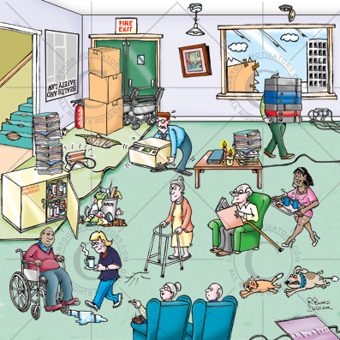

Answers:

Illness & Medication

Certain medical conditions including inner ear bacterial infections can affect a person’s balance and therefore increase the risk of them falling.

When a Service User is diagnosed with an illness it would be prudent to ask the GP whether this illness could potentially have an effect to the persons balance. This is also the same for any side effects of medication the Service User may be prescribed.

This form of communication coupled with a new awareness of the Service Users condition and treatment can reduce the risk of a fall.

**Should the GP not be available it is advised to call 111 for guidance on illnesses and medication.**

Reduced Mobility

Unfortunately sometimes, due to the aging process or certain physical conditions, the body can become susceptible to reduced mobility or balance. When this happens care should be taken to understand the causes of the falls as well as underlying mental health issues associated, such as fear and depression.

Post Falls

Policies & Procedures

**No Lift and Minimal Lift Policies**

Care workers are not expected to ‘lift’ service users i.e. pick them up from the floor using only bodily force. In the case of non-injury falls, it may be possible to facilitate a service user off the floor using verbal cues or it may be necessary to use appropriate manual handling techniques with support from additional members of staff if required and/or use a hoist or other manual handling aid.

The Ambulance Service is not commissioned to provide a lifting service for patients who are not injured. There is an expectation that under your duty of care, appropriate manual handling techniques will be used to assist service users who have fallen and an ambulance will only be requested when there is a major injury/illness or apparent major injury/illness to the service user (please see flow chart below). If a 999 call centre operative requests a carer **lift** a service user, the expectation would be for the carer to facilitate the service user off the floor using either verbal cues or appropriate manual handling techniques as above.

Under the Health and Social Care act 2008, it is understood that there are inherent risks in carrying out care and treatment and a post fall response will not be considered unsafe if providers can demonstrate that they have taken all reasonable steps to ensure the health and safety of the person using their services and to manage risks that may arise during care and treatment.

**POST FALLS GUIDANCE: CARE HOMES**

|  |
| --- |
| **RESIDENT HAS A FALL – NURSE OR MANAGER MUST MAKE AN ASSESSMENT OF INJURY PRIOR TO MOVING THE RESIDENT** |

|  |  |  |
| --- | --- | --- |
| **NON-INJURY**   * Conscious and responds as usual * No apparent injury * No head injury * No complaints of pain/discomfort (verbal/nonverbal) * Mobility unaffected – able to move limbs on command or spontaneously * No signs of bruising/wounds * No signs of limb deformity/shortening/ rotation | **MINOR INJURY**   * Conscious and responds as usual * Some bruising * Slight skin wounds * Slight discomfort * Mobility unaffected – able to move limbs as usual on command or spontaneously * No head injury * No signs of limb deformity/shortening/ rotation | **MAJOR INJURY**   * Loss of consciousness * Reduced consciousness * Signs of head injury * Airway/breathing problems * Haemorrhage/bleeding * Suspected injury to a resident taking anticoagulants * Chest pain * Limb deformity * Pain/Discomfort * Swelling * Extensive bruising * Unable to move limbs/joints on command * Dizziness or vomiting * Any fall from a height above 2 metres * Any other concerns by carer |

|  |  |  |
| --- | --- | --- |
| Assist to a comfortable place (using available equipment/verbal cues as appropriate) – this may include a request for an additional carer via normal processes  Observe resident for 24 hours for pain or any changes in condition  Document all findings | Administer First Aid as required and assist to a comfortable place (using available equipment/ verbal cues as appropriate) – this may include a request for an additional carer via normal processes  Observe patient for 24 hours for new/increasing pain or any changes in condition  Contact GP or NHS 111 for advice and follow up as appropriate  Document all findings | **DO NOT MOVE RESIDENT**  **CALL 999 FOR AMBULANCE**  **ADMINISTER FIRST AID AS REQUIRED**  **DOCUMENT ACTIONS** |

|  |
| --- |
| If there are any changes in the resident’s condition which cause concern, contact the GP or NHS 111 for follow up. Contact 999 in an emergency |

**ADDITIONAL NOTES FOR CARE AGENCIES**

**Unwitnessed Falls:** The carer (with support from senior members of staff) should use their judgement and knowledge of the service user when discovering an unwitnessed fall. For example, if a fall is discovered on the first visit of the day, there is clearly a risk that the service user has been on the floor all night. Even if the service user appears uninjured, in this situation, additional advice from GP or NHS 111 may be required. Where such advice is sought it is important to mention that the fall was unwitnessed when explaining the purpose of the call.

**Response Time from GP/ NHS 111:** We recognise that there may be a significant delay in getting a response from service users’ GP or the NHS 111 service for advice and this may cause time pressure. We recommend that wherever possible the visit be extended and the carer should wait with the service user until they are called back however, when this is not possible, providers are advised to utilise any other support that may be available in line with provider policies.

**24 Hour Observation:** We recognise that observation for 24 hours post fall will often not be possible for Care Agencies to provide themselves. Providers are advised to utilise any other support with this that may be available. This could include (but is not limited to):

- Use of visits later in the day (additional visits could also be requested from the Commissioners although there is no guarantee these will be approved)

- Use of a ‘Responder List’, pre agreed with the service user, consisting of family and friends who have agreed to be contacted in case of a fall. Responder may visit the service user or may choose to contact them via telephone to check on wellbeing.

- Advice sought from Care Manager if there is one

- Use of tele-healthcare if installed

**Communication Difficulties:** Where the service user is unable to provide a reliable account of the fall and any pain they may be in, the carer (with support from senior members of staff) should use their knowledge of the service user and non-verbal signs to judge the most appropriate course of action. Even if the service user appears uninjured, in this situation, additional advice from GP or NHS 111 may be required. Where such advice is sought, it is important to mention that the service user is unable to provide a reliable account when explaining the purpose of the call. It is also important that any advice or suggested interventions given by the GP/NHS 111 are documented.

**Intermediate Care Referrals:** Where someone is able to or insisting on staying at home post fall and their normal functioning is impacted, an intermediate care referral may be appropriate for rehabilitation or equipment issue to reduce further risk and to allow them to remain safely at home. For Service Users registered with a South Devon or Torbay GP, please contact 01803 219700 to make a referral, for Service Users registered with a GP anywhere else in Devon, please contact 0345 155 1007 to make a referral.

Post Falls Recording

Depending on your organisations policies and Procedures you may have different reporting tools. That said, in all cases, falls are required to be recorded.

We will now take a look at an example sheet:

|  |  |  |  |  |  |
| --- | --- | --- | --- | --- | --- |
| **POST FALLS GUIDANCE RECORDING** | | | | | |
| Name of Resident: |  | | | | |
| Date and Time of Fall: |  | | | | |
| Place of Residence: |  | | | | |
| Name of person completing Guidance: |  | Job Title: | |  | |
| Date and Time Guidance Completed: |  | | | | |
| **Assessment** | | | | | |
| Level of consciousness | Conscious and responds as usual | Less responsive than usual | | | Unresponsive or unconscious |
| Pain and Discomfort | No pain or discomfort | Slight discomfort | | | Pain and/or some discomfort |
| Site of Pain/Discomfort: |  | | | |
| Injury and Wounds | No apparent injury, no bruising or wounds, no signs of limb deformity, shortening or rotation | Some bruising or slight skin wounds but no signs of limb deformity, shortening or rotation | | | Haemorrhage/bleeding, limb deformity, swelling or extensive bruising |
| Detail: |  | | | |
| Movement and Mobility | Mobility unaffected, able to move limbs as usual on command or spontaneously | | Unable to move limbs as usual or major change in mobility | | |
| Body chart relates to physical assessment  *Indicate location of visible injury or complaint of pain/*  *discomfort* |  | | | | |
| **Further Actions (not an exhaustive list)** | | | | | |
| Inform relatives and GP (with consent)   * Update falls prevention care plan and put in place any new interventions * Inform zone teams and discuss the need for a multifactorial falls assessment/interventions * Consider installation of Tele HealthCare * Document and inform all staff of fall * Consider referral to Intermediate Care Services* | | | | | |

**USEFUL RESOURCES**

South West Ambulance Service training videos on how to assess someone who has fallen and how to help someone who has fallen can be found here as well as some very useful training checklists:

<http://www.swast.nhs.uk/falls.htm>

Torbay and South Devon NHS Trust website provides some very useful information and training videos here:

http://www.torbayandsouthdevon.nhs.uk/services/falls-fracture-prevention-bone-health/what-to-do-if-a-fall-occurs/

The Chartered Society of Physiotherapy, Saga and Public Health England have produced a ‘Get Up and Go’ leaflet for older people which tackles common myths about falling, how to self-assess falls risk and advice on what to do if you fall (with a pictorial guide on how to get up off the floor). The leaflet can be downloaded here:

www.csp.org.uk/publications/get-go-guide-staying-steady

Devon County Council Falls Prevention Resource Pack

www.new.devon.gov.uk/providerengagementnetwork/tools_and_templates/support-planning-paperwork-suite/

A form for handover from a care home to ambulance clinicians is available here:

[www.swast.nhs.uk/Downloads/SWASFT%20downloads/carehomehandover_form.pdf](http://www.swast.nhs.uk/Downloads/SWASFT%20downloads/carehomehandover_form.pdf)

For information on post falls training please contact the Horizons Centre at Torbay Hospital on 01803 656600 or training.southdevon@nhs.net

Contact Information

For further details of 3CP’s services and training please contact:

Matthew Williams

Managing Director

3CP Training

20 Windmill Gardens

Paignton

Devon

TQ3 1BL

Tel: 07535 739 598

Email: 3cptraining@gmail.com

This workbook represents 3CP Training's best efforts to understand and implement the Skills for Care Key Knowledge Sets and induction standards (C.I.S). The final responsibility for assessing a candidate's competence rests solely with the organisation where the candidate undertakes their employment.

Records of assessments will be inspected by the Care Quality Commission (CQC).

3CP Training accepts no responsibility for the assessments or the inspections conducted by external organisations.